48B. Trading the Open (Part 2/11)

Why trade the open?
  - First hour or two after the RTH open is the easiest time to find swing trades.
  - The majority of lower wick of a daily bullish candle that closed near its high, is created during the early selloff. Conversely, the majority of upper wick of a daily bearish candle that closed near its low is created during the early rally.

Most common patterns (on the open)
  - Trend from the open (not necessarily lasting all day, but at least enough for a swing profit)
  - Breakout Mode (BOM) followed by a trend. BOM is when we have at least two reversals from new high/low from the first bar (and at least 10 bars from B1 to the second of the two reversals).
  - Opening Reversal from support/resistance. For example, reversal from the EMA or from wedge, DT/L2/H2, etc.
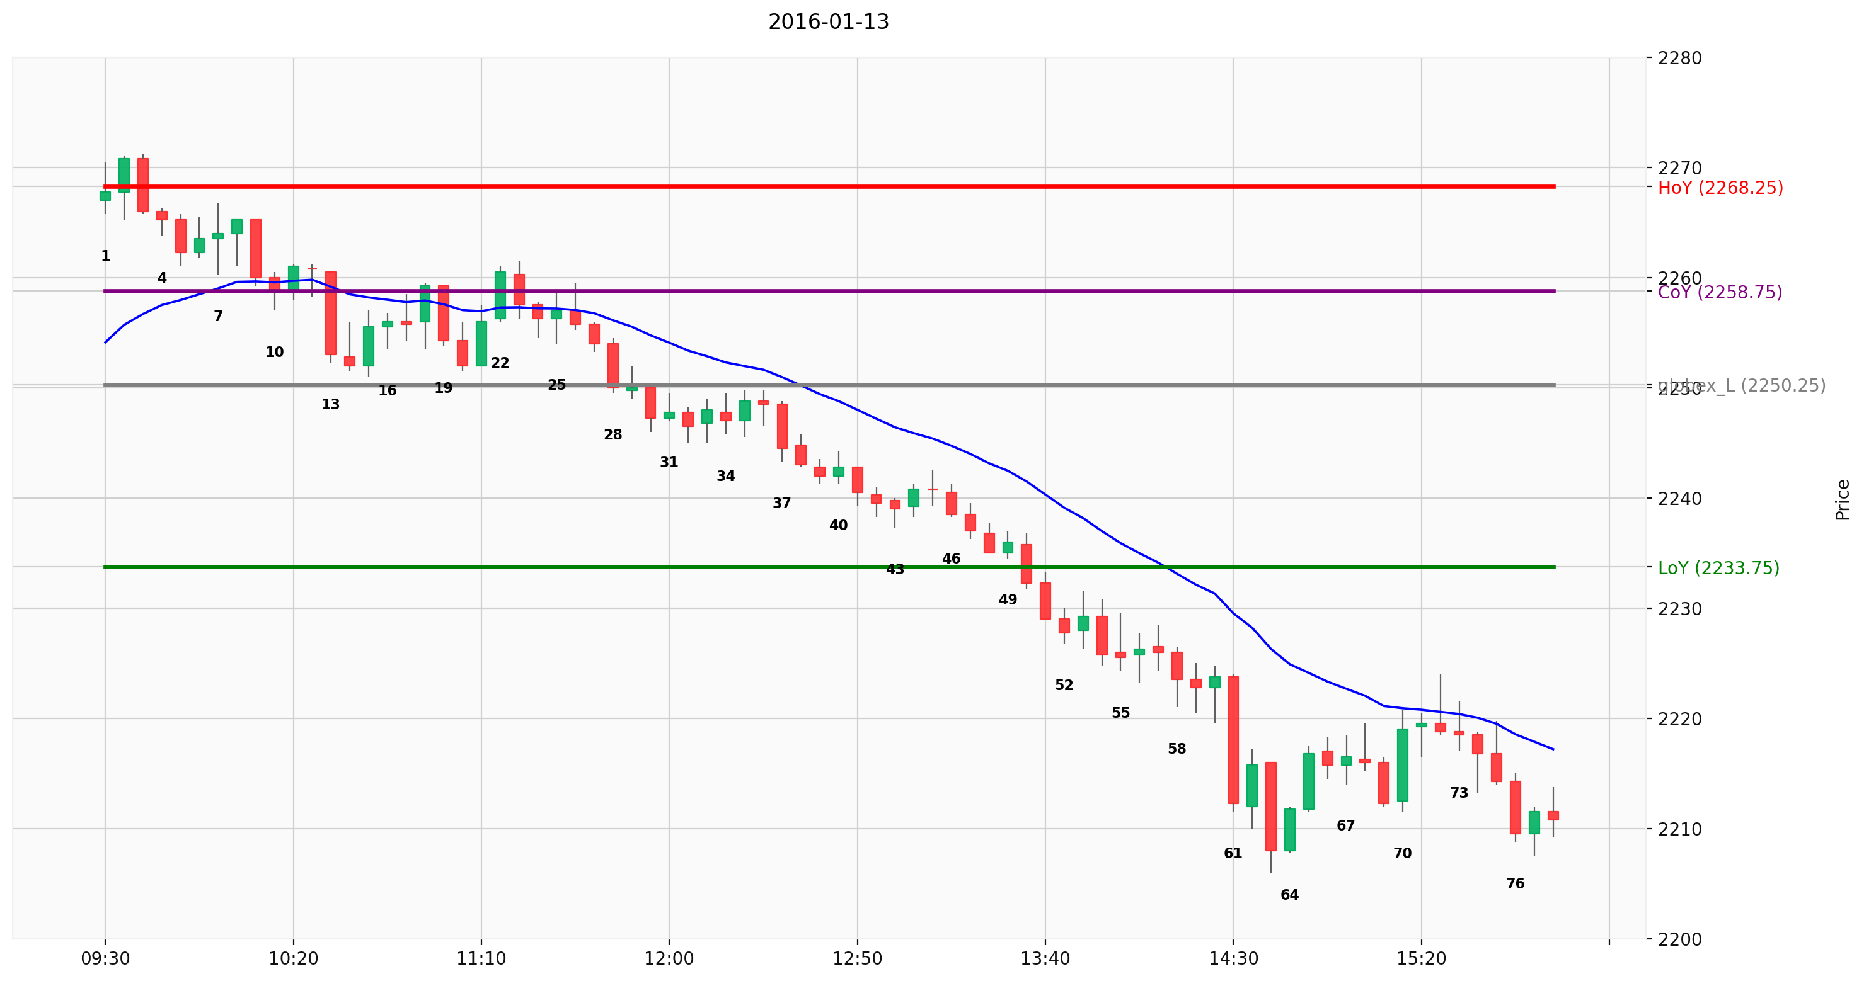Figure 1: 2016-01-13 (ES) Trend From Open
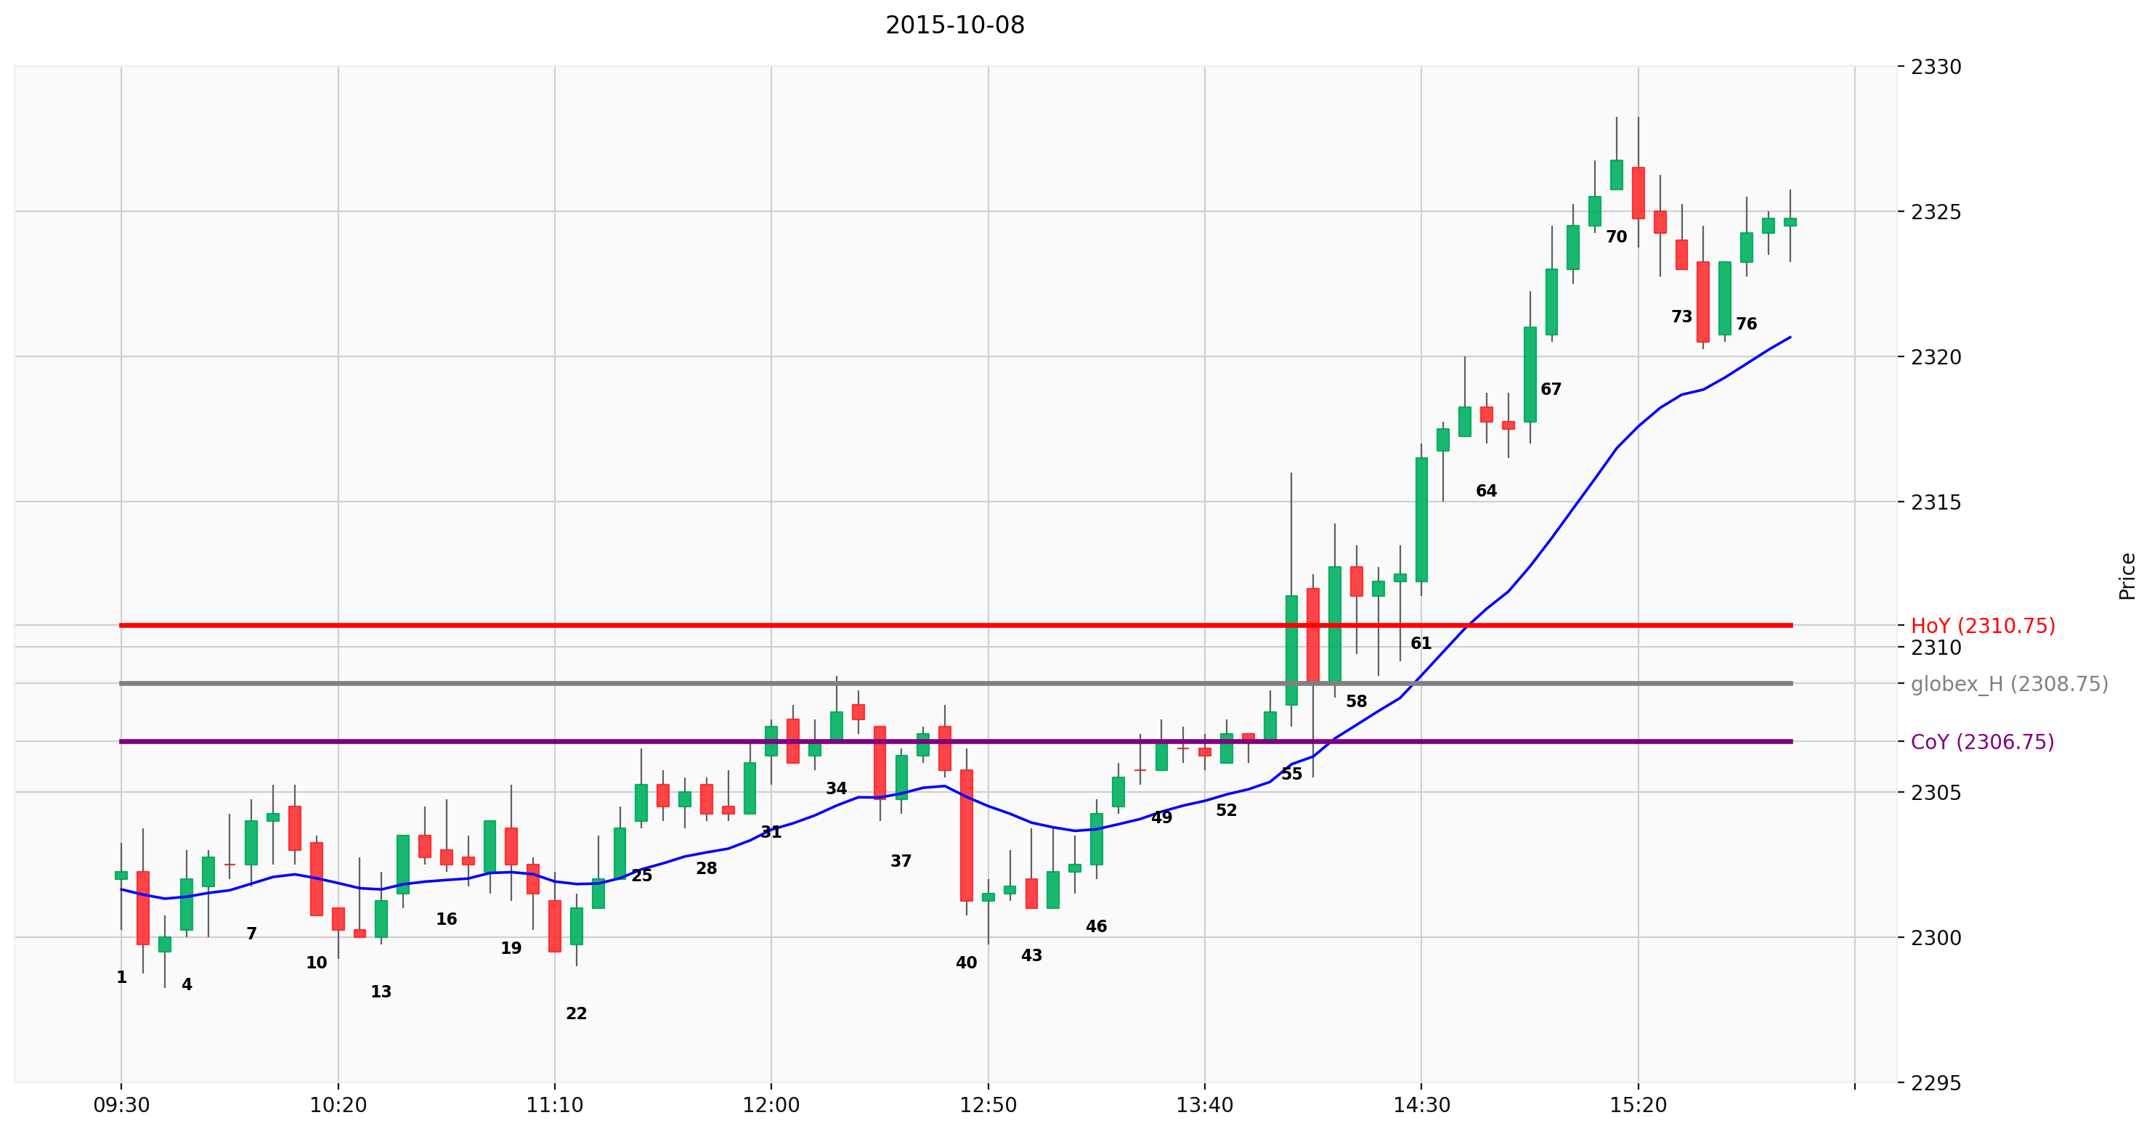Figure 2: 2015-10-13 (ES) BOM then bull trend
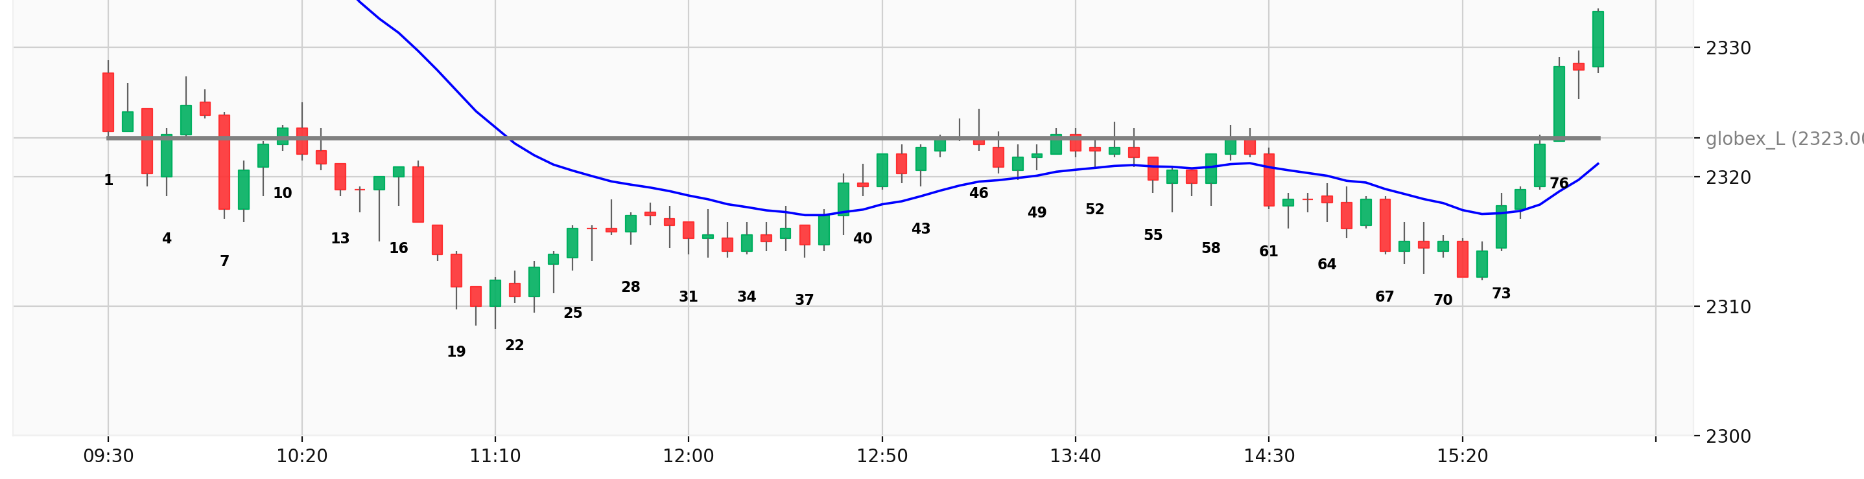Figure 3: 2016-01-04 (ES) Wedge Bottom (7,15,21)

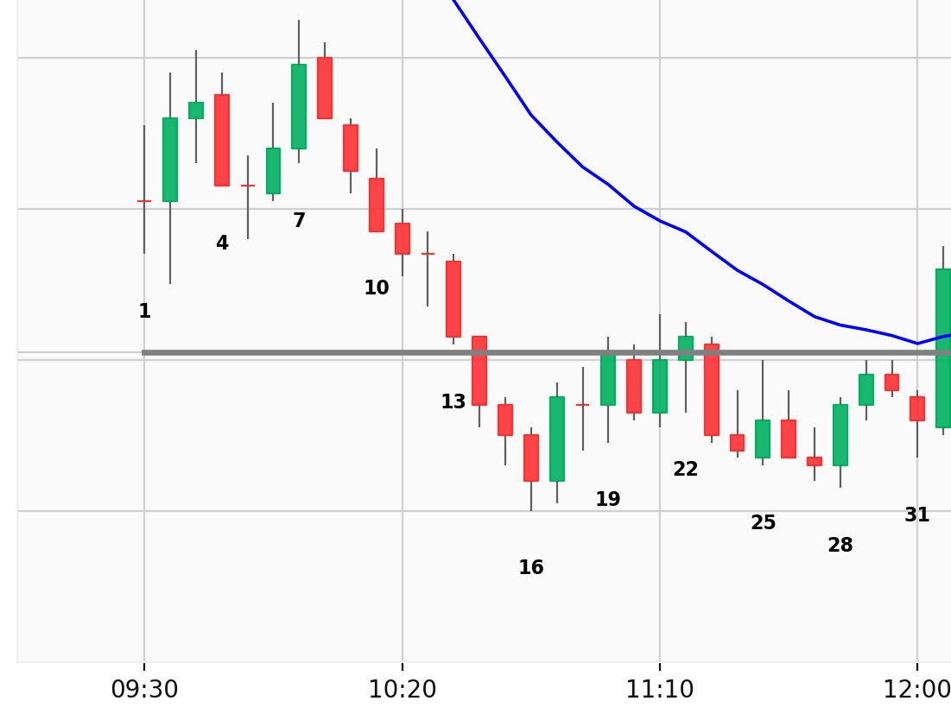Figure 4: 2015-09-22 (ES) Large Gap Down and L2 Reversal

Two Types of Trading Range
Broad Trading Range
        - There are micro-channels on both sides, or strong rally/selloff
        - Bodies are not small, and don’t overlap much
        - Example chart:
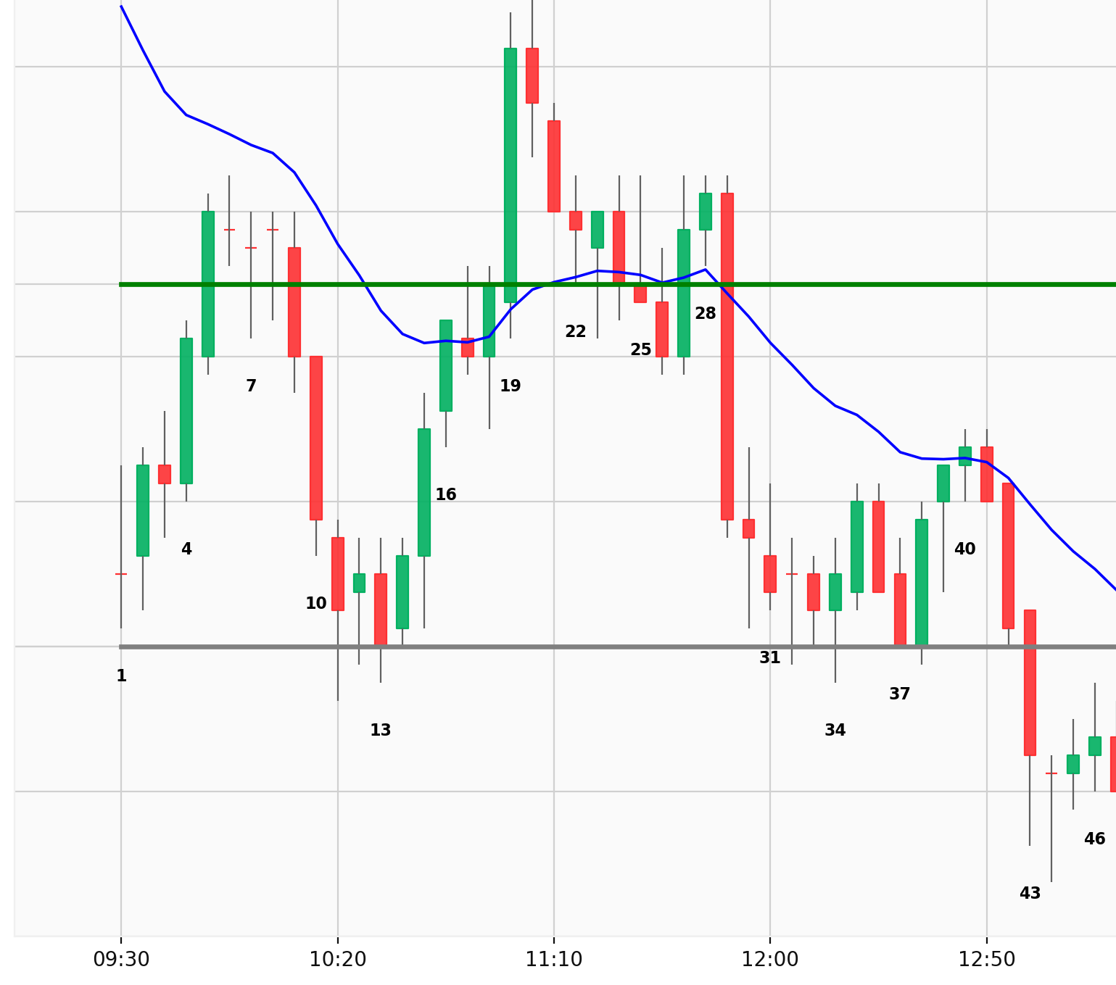Figure 5: 2015-10-27 (ES)
        - If trading range is broad enough, traders can enter with either stop or limit orders
        - Patiently wait for a setup and a good signal bar (before entering with stop)
        - If preceding bull leg was strong, wait for micro DT or 2nd entry sell (micro DB or 2nd entry buy when selling after a strong bear leg to the bottom of TR)

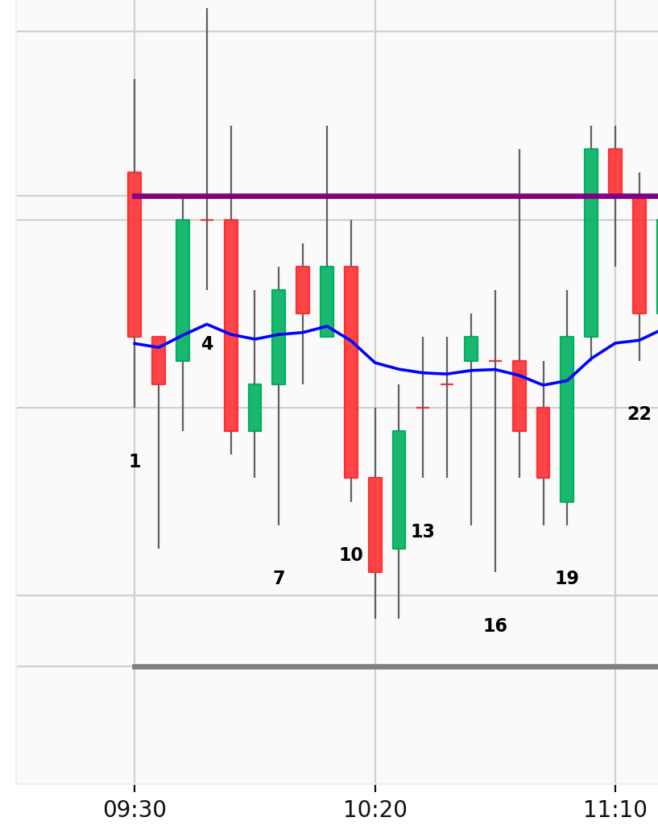Figure 6: 2015-10-12 (ES)
Tight Trading Range
          - Unlike the example above, sometimes trading range is small, lots of overlaps and reversals every 1-3 bars
          - If trading range is tight, traders should wait for a breakout
          - Only VERY experienced traders can profit by entering with limit orders and scaling in, but even then, reward is likely not worth the effort and stress of managing trades. (you should assume YOU are not at that level yet)
          - About 10% of the days will look like this all day.
When there is no good stop entries near top/bottom of developing trading range, traders often often buy close of strong bar, during a strong leg up/down, expecting at least a small 2nd leg in the same direction.

However if you do so and there is no follow through within at most several bars you should give up fast with either break even or small loss. For example if you bought B5C in Figure 5, you had the opportunity at a break even after disappointing follow through until B8. B9-B10 is a pair of ‘Give Up’ bars where bulls who didn’t get out earlier are finally giving up and covering their long.

Being Prepared
  - Be prepared and don’t be surprised by anything, regardless how unlikely you think the probability is.
  - Large surprising moves and sudden reversals and price action that seems irrational and inexplicable to you happens often at the open.
  - Strong breakouts in either direction have higher probability of reversing if it is happening at or near the open.
  - Market often has multiple reversals in both direction before finding a direction. You may have to take multiple attempts at swing profit, many of them will fail with small profit or loss, until you are finally able to catch a good swing that lasts 20-30 bars.
  - Expert traders are not surprised by any price action, and they don’t try to find explanations for strong and unanticipated moves. If market is going up, they keep buying, and if it is falling, they will keep shorting.
  - Never say market ‘ought to’ do something. Trade what you see here and now, what is in front of you, not based on what you want or think should happen.

